Part I
1. Request two numbers from the user and print the multiplication of the numbers.
Input | Process | Output
num1, num2 | Calculate product by multiplying num1 by num2 | product
IPO Model

Pseudocode
- Start
- Input num1
- Input num2
- product = num1 * num 2
- Print product
- End

Flow Chart
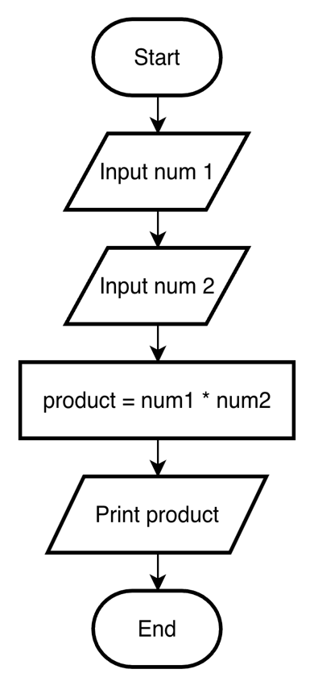

2. Determine whether a random number is greater than 50.
Input | Process | Output
- | 1. Generate randomNum  2. Determine whether randomNum is greater than 50 | Message “Random number is greater than 50” if random number is greater than 50  or “Random number is less than or equal to 50” if random number is not greater than 50
IPO Model

Pseudocode
- Start
- Generate randomNum
- If randomNum > 50
- Print “Random number is greater than 50”
- Else
- Print “Random number is less than or equal to 50”
- End

Flow Chart
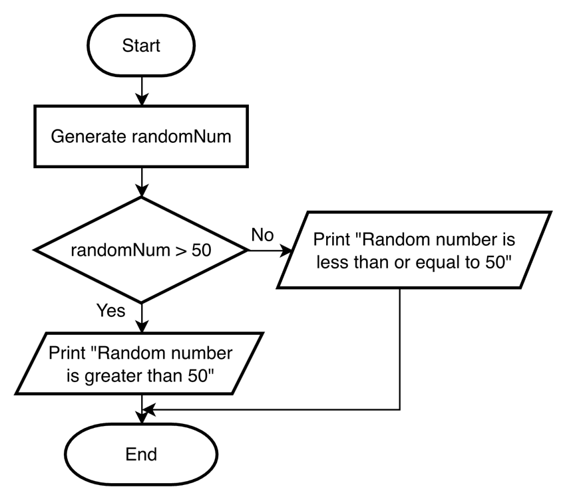
3. Print the pass/fail grade based on the mark entered by user. The passing mark is at least 40.
Input | Process | Output
mark | Determine pass/fail grade by checking if mark is greater or equal to 40 | Message “Pass” if mark is greater or equal to 40,  or “Fail” if mark is less than 40
IPO Model

Pseudocode
- Start
- Input mark
- If mark >= 40
- Print “Pass”
- Else
- Print “Fail”
- End

Flow Chart
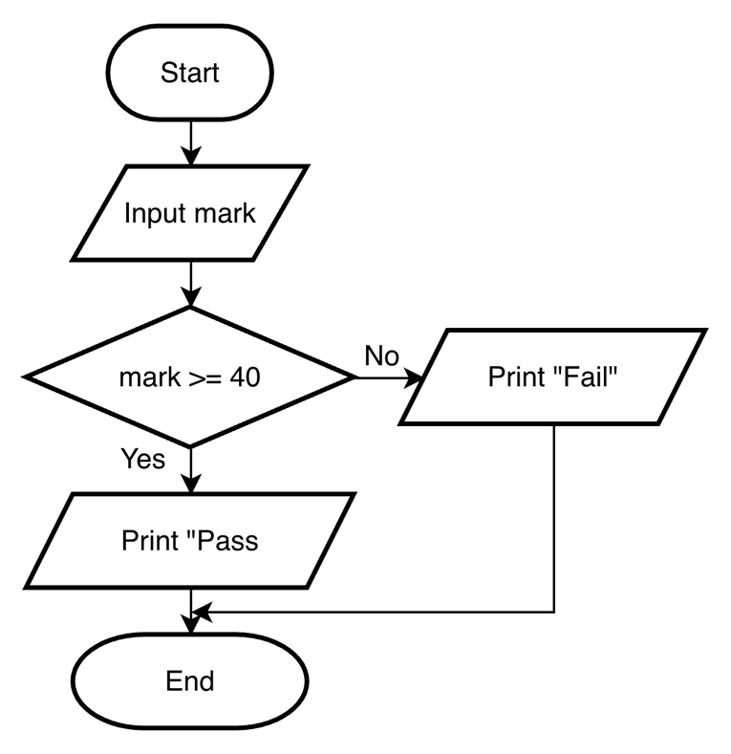
4. Print the results of the two players’ dice game.
Input | Process | Output
- | 1. Generate random number from 1 to 6 for dice1  2. Generate random number from 1 to 6 for dice2  3. Determine result by comparing dice1 and dice2 | Message “Player 1 wins” if dice1 is greater than dice2,  or “Player 2 wins” if dice2 is greater than dice1,  or “It is a tie” if dice1 is equal to dice2
IPO Model

Pseudocode
- Start
- Generate random number from 1 to 6 for dice1
- Generate random number from 1 to 6 for dice2
- If dice1 > dice2
- Print “Player 1 wins ”
- Else if dice2 > dice1
- Print “Player 2 wins”
- Else
- Print “It is a tie”
- End

Flow Chart
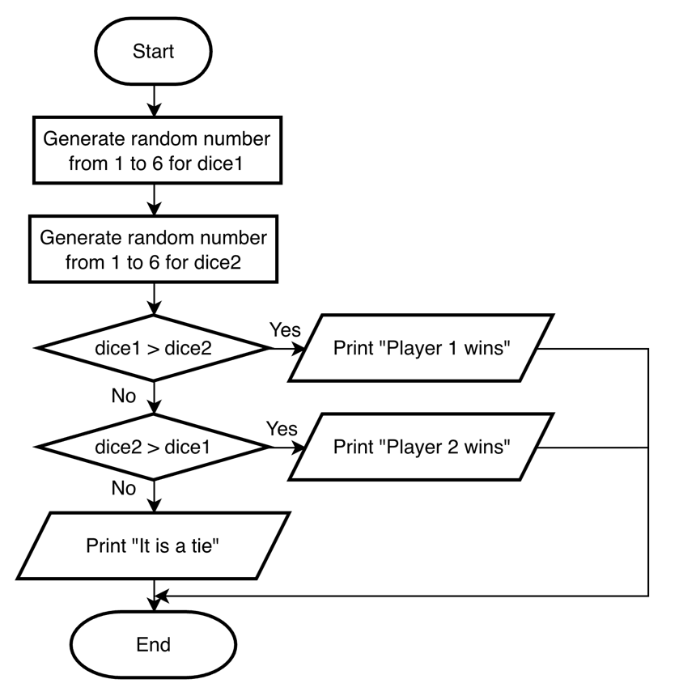
5. Print the perimeter of a rectangle.
Input | Process | Output
length, width | Calculate perimeter based on length and width | perimeter
IPO Model

Pseudocode
- Start
- Input length
- Input width
- perimeter = 2 * (length + width)
- Print perimeter
- End

Flow Chart
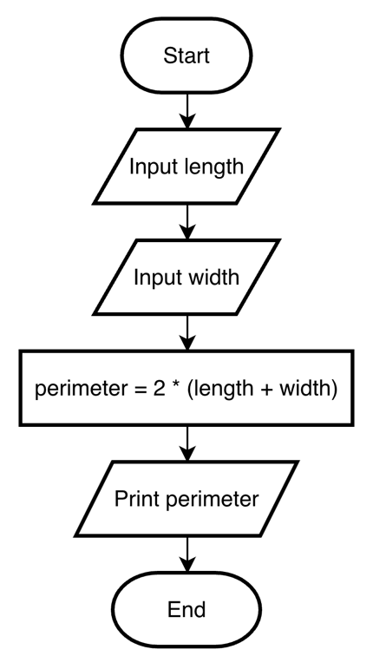
6. Print the minimum number from 10 random numbers generated by computer.
Input | Process | Output
- | 1. Generate 10 random numbers in array randomNum  2. Determine minNum among the 10 random numbers | minNum
IPO Model

Pseudocode
- Start
- Generate 10 random numbers in array randomNum
- Set minNum = randomNum[0]
- Set i = 1
- For i < 10
- If randomNum[i] < minNum
- Set minNum = randomNum[i]
- i++
- Print minNum
- End

Flow Chart
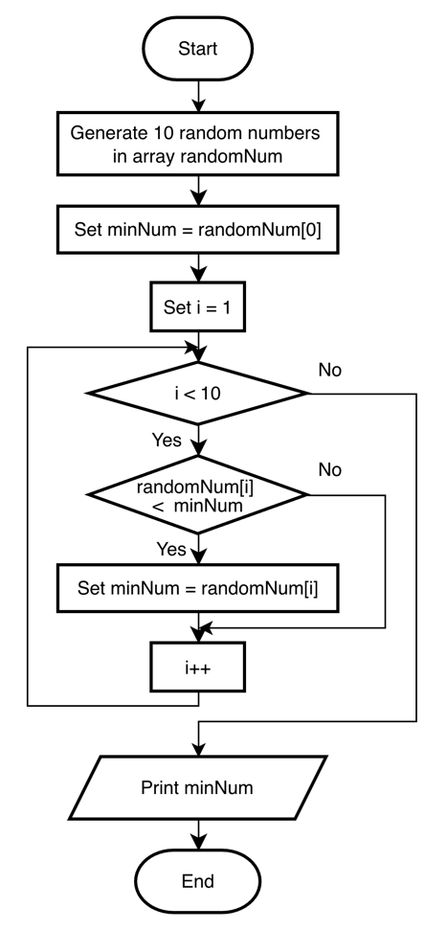
7. Print the number of odd and even number from 10 random numbers generated by computer. The random number must be from 10 – 100.
Input | Process | Output
- | 1. Generate 10 random numbers from 10 to 100 in array randomNum  2. Count oddCount and evenCount among 10 random numbers | oddCount, evenCount
IPO Model

Pseudocode
- Start
- Generate 10 random numbers from 10 to 100 in array randomNum
- Set oddCount = 0
- Set evenCount = 0
- Set i = 0
- For i < 10
- If randomNum[i] % 2 == 0
- evenCount++
- Else
- OddCount++
- i++
- Print “Number of odd number: ”, oddCount
- Print “Number of even number: ”, evenCount
- End

Flow Chart
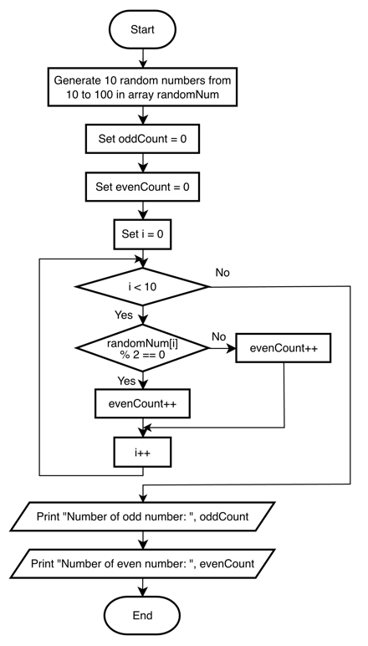
Part II
8. Count the number of alphabet U and M from a sentence entered by user.
Input | Process | Output
sentence | Count number of alphabet ‘U’ and ‘M’ in the sentence | countU, countM
IPO Model

Pseudocode
- Start
- Input sentence
- Set countU = 0
- Set countM = 0
- Set character = 0
- For character < length(sentence)
- If sentence[character] == ‘U’
- countU++
- Else if sentence[character] == ‘M’
- countM++
- character++
- Print “Number of alphabet U: ”, countU
- Print “Number of alphabet M: ”, countM
- End

Flow Chart
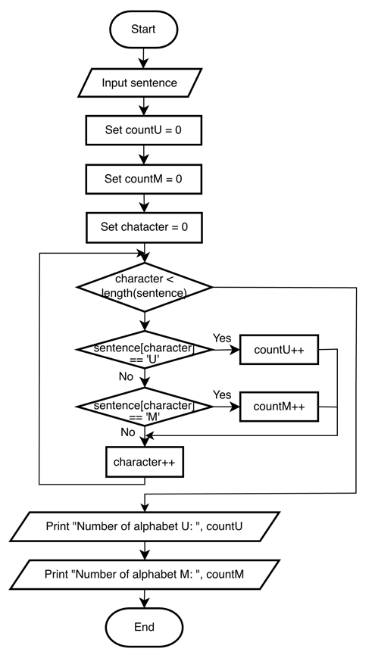
9. Display the frequency of a keyword from a web page.
Input | Process | Output
keyword, webPageContent | Count frequency of keyword in webPageContent | frequency
IPO Model

Pseudocode
- Start
- Input keyword
- Input webPageContent
- Set frequency = 0
- Set word = 0
- For word < length(webPageContent)
- If webPageContent[word] == keyword
- frequency++
- word++
- Print frequency
- End

Flow Chart
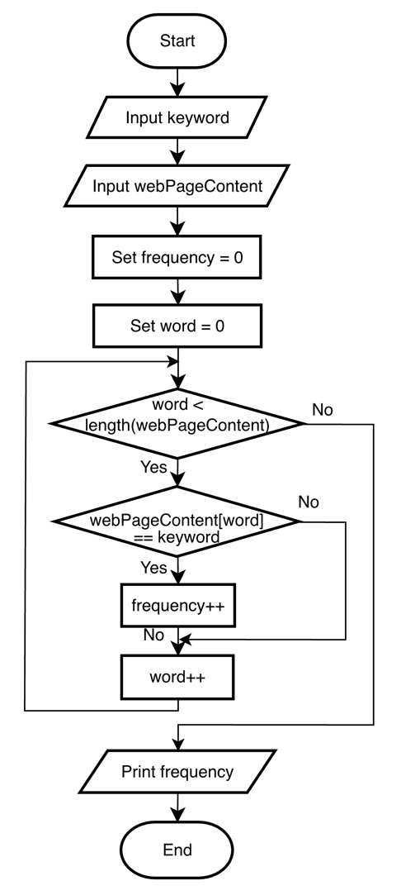
10. Display the number of female student from a random list of 100 students.
Input | Process | Output
- | 1. Generate 100 random students with their gender in array studentList  2. Count femaleCount in studentList | femaleCount
IPO Model

Pseudocode
- Start
- Generate 100 random students with their gender in array studentList
- Set i = 0
- Set femaleCount = 0
- For i < 100
- If studentList[i] == “Female”
- femaleCount++
- i++
- Print femaleCount
- End

Flow Chart
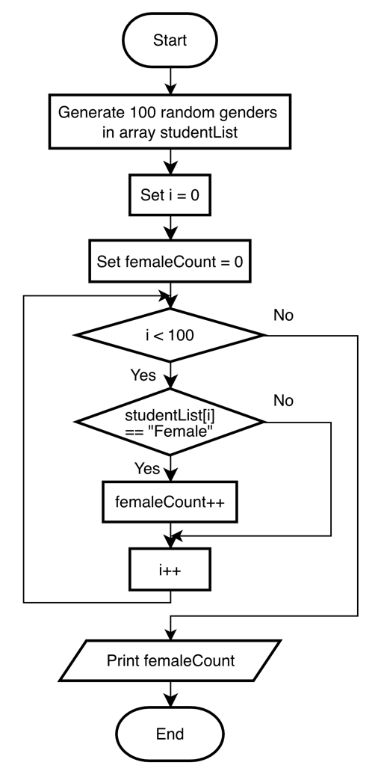
11. Display a list of 5 random numbers in descending order. (Sort)
Input | Process | Output
- | 1. Generate 5 random numbers in array randomNum  2. Sort 5 random numbers in descending order | List of 5 random numbers in descending order
IPO Model

Pseudocode
- Start
- Generate 5 random numbers in array randomNum
- Set i = 0
- For i < 4
- Set j = 0
- For j < 4 - i
- If randomNum[j+1] > randomNum[j]
- temp = randomNum[j]
- randomNum[j] = randomNum[j+1]
- randomNum[j+1] = temp
- j++
- i++
- Print randomNum
- End

Flow Chart
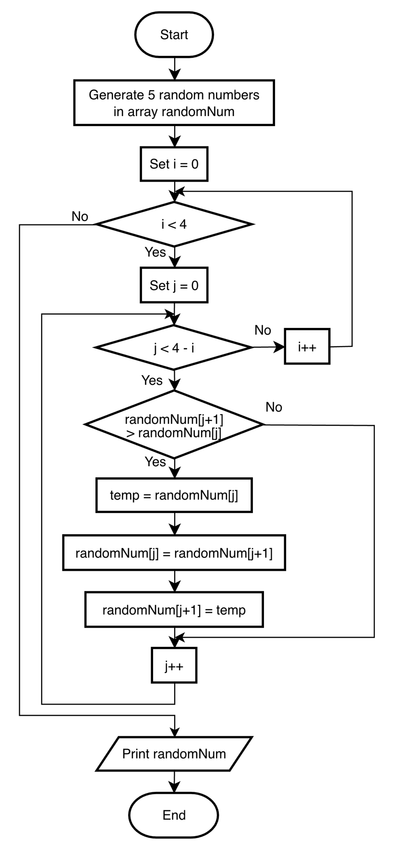
12. Guess a random number generated by computer.
Input | Process | Output
guess | 1. Generate randomNum  2. Compare guess with random number to check if it is the same | Message “Correct” if guess is equal to randomNum,  or “Too low” if guess is less than randomNum,  or “Too high” if guess is greater than randomNum
IPO Model

Pseudocode
- Start
- Generate randomNum
- Input guess
- If guess == randomNum
- Print “Correct”
- Else if guess < randomNum
- Print “Too low”
- Else
- Print “Too high”
- End

Flow Chart
